Tode-RC
Development Guide
Using Arduino-Mega Pro and Ebyte E32

Written By: TGit-Tech (10/2020)
Feel free to use: no strings attached (text content only / images respectfully referenced)
Last Updated: 2020.11.28

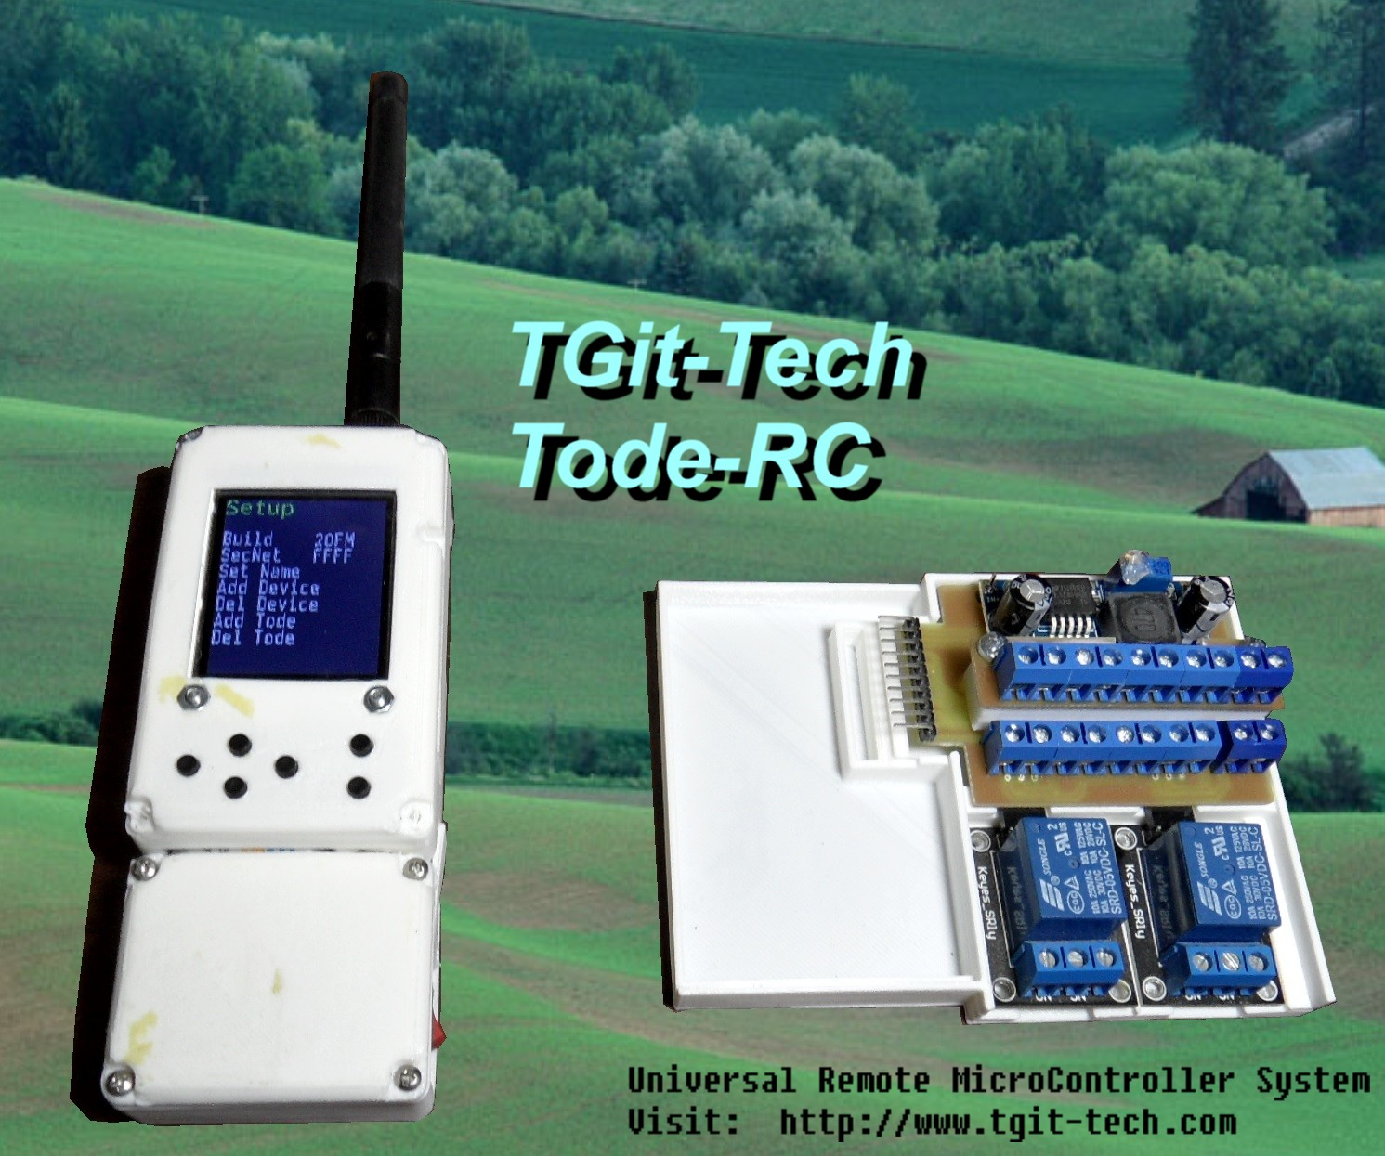

Table of Contents
1. INTRODUCTION 2
1.1 Project Goals 2
1.2 To-Do List 2
1.3 Feature Requests 2
1.4 Links 2
A. Signal Strength ( 2-Miles ) 2
2. BILL OF MATERIALS - $ 3
2.1 Tools 3
2.1.1 Required Tools 3
2.1.2 Recommended Tools 3
2.2 Electronic Modules - $17.40 3
2.2.1 Mega Pro 2560 3
2.2.2 Ebyte E32 3
2.2.3 TFT Screen 3
2.3 Electronic Parts 3
2.4 Raw Materials 3
3. PCB DEVELOPMENT 5
3.1 BackPlane 5
3.1.1 Costs 10
4. SOFTWARE 10

INTRODUCTION

Project Goals

- Features
  - Adaptable Hardware Configurations
  - User friendly IO Configurations

To-Do List

Feature Requests

Links

- The project is Open Source and its main page Resides at: https://github.com/TGit-Tech/Tode-RC
  - Releases ( All Finalized Plans, Files and Documentation ) can be downloaded at: https://github.com/TGit-Tech/Tode-RC/releases
  - This document ( most recent version ) can be seen at: https://github.com/TGit-Tech/Tode-RC/tree/main/docs
  - Pre-Built Purchasing options are available – See the projects main page link above

Signal Strength ( 2-Miles )

- Standard Signal distance is recommended for usage of up to 2-miles

  - Elevated or higher gain antennas can be purchased to extend this range

  - Test Scenario

BILL OF MATERIALS - $

Tools

Required Tools
- 3D Printer
- CNC Mill
- Soldering Iron & Solder

Recommended Tools
- Solder Reflow Oven

Electronic Modules - $17.40
- AliExpress order date 20BC
  - Ebyte E32-433T30D LoRa [ $81.60/10 ] Savings [ $159.00/20 ] = $7.95/ea
  - Mega 2560 PRO Boards [ $60.07/10 ] Savings [ $127.35/20 ] = $6.37/ea
  - WeAct 1.8-in TFT [ $2.52/1 ] Savings [ $61.51/20 ] = $3.08/ea
    - TOTAL = $17.40

Mega Pro 2560
  - Mega 2560 – Incoming Voltage 6V to 9V (peek 18Vdc)
    - Output: 5Vdc @ 800mA
    - Output 3Vdc @ 800mA

Ebyte E32
  - Ebyte E32
    - Input: 3.3V – 5.2Vdc ( Over 5.0Vdc for best preformance; over 5.2V will damage)
    - Data Rate: 0.3Kps to 19.2Kps
    - Transmit Current: 106mA, Receiving Current: 15mA

TFT Screen

Electronic Parts

Raw Materials
- 3D Prints
  - 3D Solutech White PLA ( $15.99/ea + tax is $84.75 for (5) 1Kg Rolls = $0.01695/gram )
  - Tode-Handheld-BackCover-E32-433T30D.STL 24g / 2hr 23m [ $0.10/g ] = $0.41
  - Tode-CenterCover-Mega2560 18g / 1hr 44m = $0.31
  - Tode-ScreenKeybCover-TFT1.77.STL 13g / 1hr 17m = $0.22
  - Tode-WingIO-PS+20ST+2RY 33g / 3hr 6m = $0.56
- PCB
  - (2) 4” x 3” Cu-Clad Single-Sided

PCB DEVELOPMENT

BackPlane
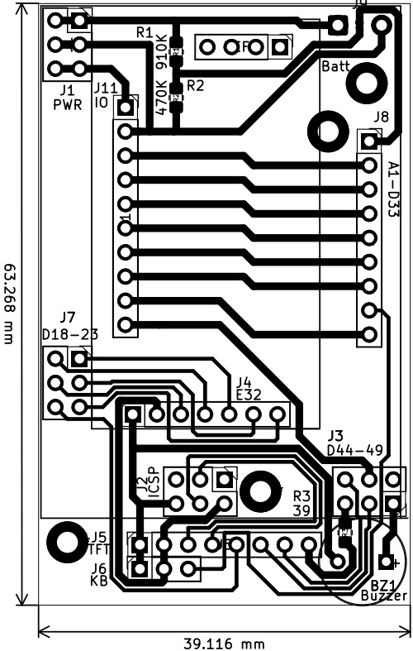
- NOTICE
  - BEFORE solding power wires to DC barrel jack; Put wires through jack nut

- Electronic Components
  - Female Dupont 2.54mm pitch connectors
    - J1-3, J7 6-Pin ( 2x3 )
    - J5 (TFT) 8-Pin Long Lead
    - J6 (KB) 3-Pin Long Lead
    - J8 (A1..) 9-Pin
    - J11 (IO) 10-Pin
  - J4 (Ebyte E32 – direct solder)
  - BZ1 Micro Piezo Buzzer
  - R1 910K-ohm 0805 SMD Resistor
  - R2 470K-ohm 0805 SMD Resistor
  - R3 39-ohm 0805 SMD Resistor

- PCB
  - (1) 4” x 3” Cu-Clad – uses only 1/2

- Connectors
  - (1) 10-Pin Female 2.54mm Dupont
  - (4) 6-Pin ( 2x3 ) 2.54mm Dupont
  - (1) 9-Pin
  - (1) 8-Pin Long Lead 2.54mm Female Dupont
  - (1) 3-Pin Long Lead 2.54mm Female Dupont

- Other
  - 22AWG Red and Black Wire
  - (2) M2.5x0.400 – 6mm long Machine Screws and Nuts

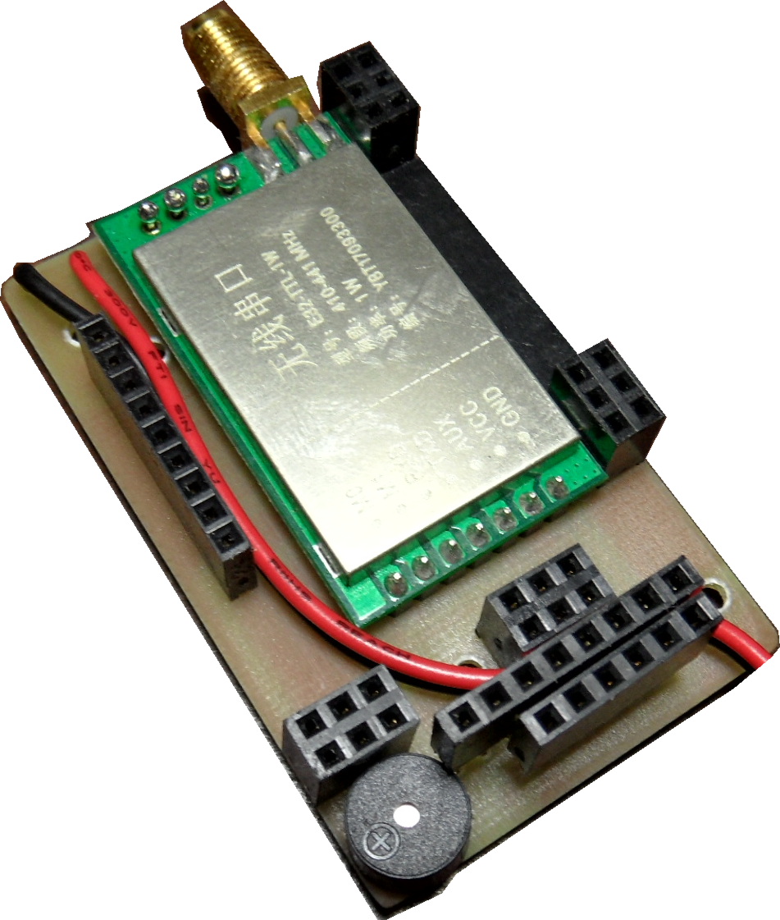Illustration 1: BACKPLANE

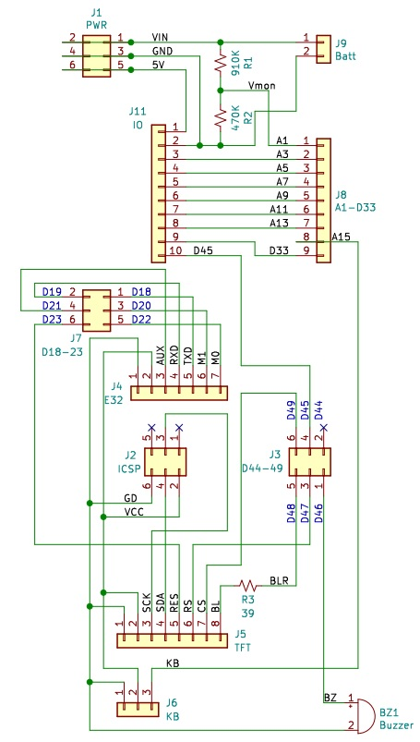Illustration 2: BACKPLANE

Costs

SOFTWARE

